Final Project Report – Programming Fundamentals
University Name: FAST (National University of Computer and Emerging Sciences)
Department: Department of Software Engineering
Course: Programming Fundamentals
Project Title: Budget Tracker
Submitted by: [Urwa Rafique] (Roll No. 25K-3066) & [Ali] (Roll No. 25K-3011)
Submitted to: [Ms. Syeda Ravia Ijaz]
Semester: Fall 2025
Date: [21-11-2025]

Abstract
A Budget Tracker is a simple console-based C program designed to help users keep an eye on their daily spending. Instead of writing expenses on paper or trying to remember where the money went, this program lets users record each expense with a category, amount, and short note. It then adds everything up, compares the total with the user’s monthly budget, and shows how much money is left or overspent.
Introduction
The Budget Tracker is a simple financial management system that allows users to keep track of their income, expenses, and savings. It provides an efficient way to monitor spending habits, manage daily transactions, and calculate balances without relying on manual record keeping.
Objectives
We propose developing a console-based Budget Tracker using the C programming language. This system will allow users to:
● Input income and expenses.
● Automatically calculate the remaining balance.
● View categorized reports for better expense management.
● Provide a simple, menu-driven interface for easy navigation.

3. System Design
System Overview
Start with a Menu Driven Interface
When the program starts show the simple menu:
- Add Income
- Add Expense
- Add Balance
- View Expense Report (by Category)
- View All Transactions
- Exit
Algorithm
- Start the program.
- When option is selected from menu interface.
- Enter Income
- Enter Expense
- Calculate Balance
    - Balance = Total Income – Total Expense
- Expense Categorization
- Display all transactions
- Keep the program running until user chooses exit
Use a loop so the menu continues until the user select “Exit”.
Input & Output
Input:
- User menu choice (1-6).
- Income Amount.
- Expense Amount.
- Expense Category (Food, Transport, Utilities, Other).
Output:
- Confirmation messages for adding income and expenses
- Total Income
- Total Expense
- Balance (Income – Expense)
- Expense report by category (Food, Transport, Utilities, Other)

4. Implementation
Language: C
Compiler / IDE: Dev C ++
Key Features
● Add income and expenses.
● Store daily/monthly transaction records.
● Automatic balance calculation.
● Categorization of expenses (e.g., food, transport, utilities).
● Simple, user-friendly console interface.
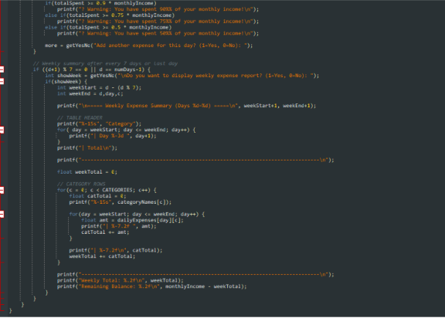
Code Snippet
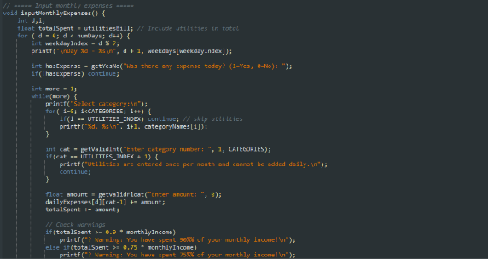

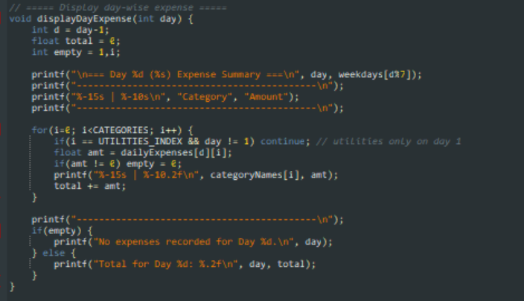
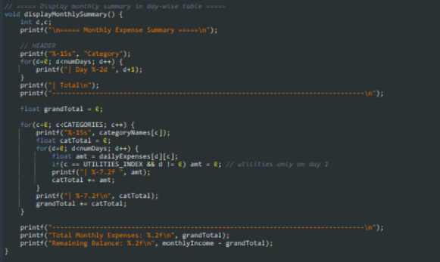

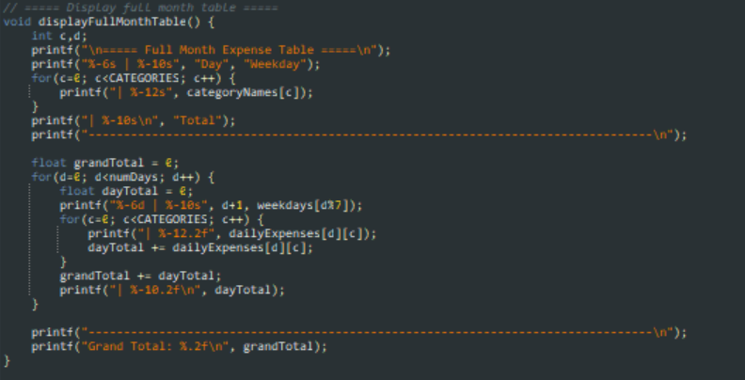

Sample Output
Enter number of days in the month (28û31): 31
Enter your monthly income: 120000
Enter Utilities bill for the month: 12000
Day 1 - Monday
Was there any expense today? (1=Yes, 0=No): 1
Select category:
1. Food
2. Transport
4. Health
5. Entertainment
6. Other
Enter category number: 1
Enter amount: 1200
Add another expense for this day? (1=Yes, 0=No): 0
Day 2 - Tuesday
Was there any expense today? (1=Yes, 0=No): 2
Invalid input! Enter 1 for Yes, 0 for No.
Was there any expense today? (1=Yes, 0=No): 1
Select category:
1. Food
2. Transport
4. Health
5. Entertainment
6. Other
Enter category number: 2
Enter amount: 1870
Add another expense for this day? (1=Yes, 0=No): 0
===== Full Month Expense Table =====
Day | Weekday | Food | Transport | Utilities | Health | Entertainment| Other | Total
--------------------------------------------------------------------------------
1 | Monday | 1200.00 | 0.00 | 12000.00 | 0.00 | 0.00 | 0.00 | 13200.00
2 | Tuesday | 0.00 | 1870.00 | 0.00 | 0.00 | 0.00 | 0.00 | 1870.00
3 | Wednesday | 0.00 | 0.00 | 0.00 | 120.00 | 0.00 | 0.00 | 120.00
4 | Thursday | 0.00 | 0.00 | 0.00 | 0.00 | 1000.00 | 0.00 | 1000.00
5 | Friday | 0.00 | 0.00 | 0.00 | 0.00 | 0.00 | 300.00 | 300.00
6 | Saturday | 0.00 | 0.00 | 0.00 | 0.00 | 0.00 | 0.00 | 0.00
7 | Sunday | 0.00 | 0.00 | 0.00 | 0.00 | 0.00 | 0.00 | 0.00
8 | Monday | 0.00 | 0.00 | 0.00 | 0.00 | 0.00 | 0.00 | 0.00
9 | Tuesday | 0.00 | 0.00 | 0.00 | 0.00 | 0.00 | 0.00 | 0.00
10 | Wednesday | 0.00 | 0.00 | 0.00 | 0.00 | 0.00 | 0.00 | 0.00
11 | Thursday | 0.00 | 0.00 | 0.00 | 0.00 | 0.00 | 0.00 | 0.00
12 | Friday | 0.00 | 0.00 | 0.00 | 0.00 | 0.00 | 0.00 | 0.00
13 | Saturday | 0.00 | 0.00 | 0.00 | 0.00 | 0.00 | 0.00 | 0.00
14 | Sunday | 0.00 | 0.00 | 0.00 | 0.00 | 0.00 | 0.00 | 0.00
15 | Monday | 0.00 | 0.00 | 0.00 | 0.00 | 0.00 | 0.00 | 0.00
16 | Tuesday | 0.00 | 0.00 | 0.00 | 0.00 | 0.00 | 0.00 | 0.00
17 | Wednesday | 0.00 | 0.00 | 0.00 | 0.00 | 0.00 | 0.00 | 0.00
18 | Thursday | 0.00 | 0.00 | 0.00 | 0.00 | 0.00 | 0.00 | 0.00
19 | Friday | 0.00 | 0.00 | 0.00 | 0.00 | 0.00 | 0.00 | 0.00
20 | Saturday | 0.00 | 0.00 | 0.00 | 0.00 | 0.00 | 0.00 | 0.00
21 | Sunday | 0.00 | 0.00 | 0.00 | 0.00 | 0.00 | 0.00 | 0.00
22 | Monday | 0.00 | 0.00 | 0.00 | 0.00 | 0.00 | 0.00 | 0.00
23 | Tuesday | 0.00 | 0.00 | 0.00 | 0.00 | 0.00 | 0.00 | 0.00
24 | Wednesday | 0.00 | 0.00 | 0.00 | 0.00 | 0.00 | 0.00 | 0.00
25 | Thursday | 0.00 | 0.00 | 0.00 | 0.00 | 0.00 | 0.00 | 0.00
26 | Friday | 0.00 | 0.00 | 0.00 | 0.00 | 0.00 | 0.00 | 0.00
27 | Saturday | 0.00 | 0.00 | 0.00 | 0.00 | 0.00 | 0.00 | 0.00
28 | Sunday | 0.00 | 0.00 | 0.00 | 0.00 | 0.00 | 0.00 | 0.00
29 | Monday | 0.00 | 0.00 | 0.00 | 0.00 | 0.00 | 0.00 | 0.00
30 | Tuesday | 0.00 | 0.00 | 0.00 | 0.00 | 0.00 | 0.00 | 0.00
31 | Wednesday | 0.00 | 0.00 | 0.00 | 0.00 | 0.00 | 0.00 | 0.00
--------------------------------------------------------------------------------
Grand Total: 16490.00
Remaining Balance: 103510.00
5. Testing & Results
Transaction | Type | Category | Amount
1 | Income | - | 8000
2 | Expense | Food | 900
3 | Expense | Transport | 850
4 | Expense | Entertainment | 1200
5 | Expense | Utilities | 2500
6 | Expense | Health | 750
7 | Expense | Other | 500

Total Expense = 900 + 850 + 1200 + 2500 + 750 + 500 = 6700
Current Balance = 8000 – 6700 = 1300

6. Conclusion, Limitations & References
Conclusion
The Budget Tracker project shows how a small C program can make everyday money management much easier. By allowing users to record their expenses, calculate totals, and compare them with their monthly budget, the system removes the guesswork from keeping track of finances. It demonstrates how basic programming concepts—like arrays, loops, conditions, and functions—can come together to solve a real-life problem in a simple and practical way.

Limitations
- Data is lost when the program closes (no file handling implemented).
- Only basic text menus are available (console-based UI).
- Limited categories and no option to customize them.
- No validation for incorrect or invalid user input.
- Single-user use only; no multiple account support.

Future Enhancements
- Add file handling to store income and expense records permanently.
- Introduce a graphical or web-based interface.
- Allow users to search, sort, and edit their transactions.
- Add customizable categories for better personalization.
- Implement monthly reports, charts, and spending analysis.
- Add password protection or multiple user profiles.

References
• Let Us C by Yashavant P. Kanetkar
• https://www.programiz.com/c-programming
• https://www.geeksforgeeks.org/c-programming-language

